Background
Current trends and recent developments on the front of phylogenetic codon substitution models
Thibault Latrille
Master BioSciences, Département de Biologie, Ecole Normale Supérieure de Lyon.
UMR CNRS 5558 Laboratoire de Biométrie et Biologie Évolutive (LBBE)
2016-11
Keywords : codon-substitution models; synonymous/non-synonymous substitution; positive/adaptative selection; negative/purifying selection; phylogeny;
Abstract here
Phylogenetic reconstruction seek to infer past evolutionary history of life on Earth. However, scientists we are constrained to solely access present-day populations and extinct fossils. One approach to circumvent this limitation is to study the evolution of molecular sequences backward in time, based on the present day molecular sequences. In this molecular framework, evolution is generally seen as a stochastic process, and the interplay between point mutations and the selection of theses mutations leads to substitutions in the sequences over time. Thus, molecular evolutionary biologists design substitution models of the sequences, and compute how likely we would observe the present-day molecular sequences, given a past-history scenario and a model of substitutions.
One major assumption of substitution models is independence between sites, meaning any position of the sequence has its own independent evolutionary process and a substitution at one position does not affect the substitution process at other positions. The motivation for this assumption is rooted in computational complexity rather than biological meaning, and crucially constrains the modeling process.
Under the site-independence assumption, the modeling approach essentially depends on the nature of the sequence under study. For example, non-coding DNA sequences are subject to very different evolutionary forces compare to protein coding DNA sequences, and must be addressed differently. In this review, I will focus on substitution models designed to address solely protein coding DNA sequences. In such coding DNA sequences the mutation process occur at the DNA level, but selection process occurs at the protein level in first approximation. Thus studying protein coding DNA sequences at the nucleotide level has a major shortcoming of not taking into account the true underlying selection process, which can lead to false conclusion in the phylogenetic reconstruction. One simple approach to resolve this conflict is to study the evolutionary history of the protein instead of the DNA sequence, meaning translating nucleotide sequences into amino-acid sequences, and design a model at the amino-acid level. Equally, amino-acid substitution models has also the major shortcoming of not taking into account that the mutation process occurs at the nucleotide level. Indeed, amino-acid are coded by triplet of nucleotides (4^3=64 modalities) and converted to amino-acid (20 modalities). And ultimately, when studying sequences at the amino-acid level, the degeneracy of the genetic code leads to loss of information present in the mutated DNA sequences.
For protein coding sequences, DNA and amino-acid substitution models both fail to take into account either the selection or the mutation process. These shortcomings are both addressed by codon models, basically combining the best of both models by studying nucleotides in triplets instead of independently. In a codon substitution model, a mutation of a nucleotide in a triplet will either be synonymous, meaning not changing the translated amino-acid, or non-synonymous, meaning the translated amino-acid will be different. Codon substitution models can estimate explicitly the ratio of the non-synonymous over the synonymous substitution rates, denoted ω. Moreover, assuming there is no selection acting on synonymous mutation, ω is absorbing the signal of an excess in the rate of non-synonymous substitution, leading to ω>1 and meaning the protein is under adaptive selection. On the opposite, a default of non-synonymous substitution, leading to ω<1, means the protein is under purifying selection.
The seemingly flaw of the degeneracy of the genetic code is in fact an advantage when one devise a model at the codon level in DNA sequences. And one can identify interplay between mutation acting at the DNA level, and positive or negative selection acting at the protein level. Thus codon substitution models are crucial for a better modeling of the underlying evolution of protein coding DNA sequences, and consequently allow a better reconstruction of phylogenies. In this review, we will study different codon substitution models, based on different assumption made on the underlying evolutionary process. First we will review so called neutral models , based on the original codon substitution models. Secondly, we will review nearly-neutral models, explicitly including the purifying selection as a null hypothesis. And finally, we will review comparisons of the models and their refinements, on simulated and real data.

Detecting deviation from neutrality
The first codon substitution models, derived separately by Muse and Gaut[1] and Goldman and Yang[2], both in 1994, estimate a single parameter ω , namely the ratio of the non-synonymous over the synonymous substitution rates, capturing any deviation from neutrality (see box 2) over the entire sequence and along all branches of the phylogenetic tree. The parameter ω, estimated by maximum likelihood (see box 1), is statistically tested against the null hypothesis of neutrality (ω=1).
Box 1. Definitions.
Substitution: Point mutation appears in only on individual in the population, and when it reaches fixation in the population it is called a substitution.
Red-Queen: Evolutionary hypothesis that proposes that organisms must constantly adapt, evolve, and proliferate not merely to gain reproductive advantage, but also simply to survive while pitted against ever-evolving opposing organisms in an ever-changing environment.
Neutral codon substitution model: The probability of fixation a non-synonymous mutation does not depend on the amino-acid encoded.
Nearly-neutral codon substitution model: The probability of fixation a non-synonymous mutation depends on both the amino-acid preferences encoded by the original codon and the mutated codon.
Mixture model: Probabilistic model for representing the presence of subpopulations within an overall population, without requiring that an observed data set should identify the sub-population to which an individual observation belongs.
Markov chain: Stochastic process with property that the next state of the process depends only on the present state of the process and not on its past
Likelihood function: Probability of observing the data given the parameters of the statistical model. Note this a function of solely the parameters of the model, the observed data are fixed.
Maximum likelihood (ML): Method of estimating the parameters of a model given the data, by finding the parameter value that maximize the likelihood function.
Akaike information criterion (AIC): Measure of the relative quality of a maximum likelihood estimated given the data, penalizing for too many parameters in the model.
Likelihood ratio test (LRT): Statistical test used to compare the goodness of fit of two models, one of which (the null model) is a special case of the other (the alternative model)
Bayesian statistics: Bayesian inference derives the posterior distribution of the parameter as a consequence as both a prior distribution on the parameter and the likelihood function of the data.
Prior distribution: Probability distribution that would express one's beliefs about a parameter of the model before the data is taken into account.
Posterior distribution: Probability distribution of a parameter of the model conditioned on randomly observed data and the prior distribution.
Markov Chain Monte Carlo (MCMC): Class of algorithms for sampling from a probability distribution (usually posterior distribution in Bayesian inference) based on constructing a Markov chain that has the desired distribution of its equilibrium distribution.
Bayes factor: Ratio of the posterior probability of two competing hypotheses, usually a null and an alternative. The posterior probability is conditioned on randomly observed data and on the prior distribution of the parameters of the competing hypotheses.
Thermodynamic Iintegration: Method used to compute the Bayes factor of two models by generating a MCMC that samples along a continuous path between the two models.
Dirichlet process (DP): Family of stochastic processes whose realizations are probability distributions. In other words, a Dirichlet process is a probability distribution whose range is itself a set of probability distributions. It is often used in Bayesian inference to describe the prior knowledge about the distribution of random variables. Meaning, how likely it is that the random variables are distributed according to one or another particular distribution.
Codon usage bias: Differences in the frequency of occurrence of synonymous codons in protein coding DNA, reflecting a balance between mutational biases and natural selection for translational optimization.
Mc-Donald Kreitman (MK) test: Compares the amount of variation within a species (polymorphism) to the divergence between species (substitutions) at two types of sites, synonymous and non-synonymous.
Although the success of the original codon model as the first DNA sequence evolution model allowing for detection of protein adaptation, it had two shortcomings. A first mathematical shortcoming is that even if one does not get a statistical departure from neutrality (ω=1), it could be due to a mixture of both adaptive and purifying process that cannot be untied since ω is a global parameter over the entire sequence. A second shortcoming of the method, rooted in biological principle, is that positive selection often operates against a background of strong negative selection. Indeed mutation that disrupt the protein conformation or any biological requirements are strongly selected against. As a result of basal purifying selection, the overall ω of a sequence is typically greatly below 1, even in the presence of an adaptive process. The consequence is that evolutionary biologists focused their effort on detecting the presence of adaptive selection (ω>1), since detecting an ω lower than 1 was biologically expected for any protein.
Regarding to the flaws of the initial codon models, It has been rapidly recognized that the parameter ω should not been estimated globally over the entire sequence. The codons need to be separated into different categories, meaning different evolutionary regimes: neutral (ω=1), adaptive (ω>1) or purifying (ω<1). In such so called sites models, the category each codon falls into is estimated by maximum likelihood. Moreover, the number of categories can be drawn using finite mixture (see box 1)[3][4][5]. In finite mixture models, the number of categories that increase the goodness of fit of the model can be asserted by the use of Akaike Information Criterion (AIC, see box 1). Using AIC, the computations usually estimate a number of categories tending to infinite, ultimately suggesting that each codon should have it’s own ω[6]. In the Bayesian framework, in contrast to maximum likelihood, the flexibility of the computation mainly done by Markov Chain Monte Carlo (MCMC, see box 1) allows one the draw ω from an infinite mixture, usually using a Dirichlet process (see box 1), giving a posterior distribution of the parameter ω[7].
Box 2. Mathematical definition of the substitutions codon models.
Beside a site refinement, a time refinement of the initial methods has been studied[8]. The motivation was to allow for the parameter ω to be estimated only on a subset of the phylogeny, based on biological assumption. For example, such models can detect an adaptive process ongoing during the divergence of one lineage, this can allow for the detection of the proteins responsible for speciation.
Naturally, both these space (site models) and time (branch model) refinement mentioned above where combined in so called branch-site models [9][10][11][12]). The fine-grained tunning of site-branch models increased statistical power by seeking short and strong episodes (time component) of adaptive selection on a background of purifying selection (site component). However, in the case of red-queen processes (see box 1) ongoing on the protein, the episodes detected by branch-site models would merely be a small fraction of the underlying adaptation. Indeed the overall tree is under adaptive process and one cannot contrast a branch to the rest of the tree.
Mathematically (see box 2), the lack of sensitivity of neutral models can be tracked to the assumption that the substitution rate is the same for any non-synonymous change. This assumption of equal amino-acid preference means that the probability of reaching fixation is the same for any non-synonymous mutation, regardless of from which amino-acid to which amino-acid the mutation occurs. This is a very strong assumption for studying evolution of protein-coding sequences.
Contrasting to neutral models, the mutation-selection codon models reviewed in the next paragraph relax the assumption of neutrality by introducing different amino-acid preferences.

Detecting deviation from nearly-neutrality
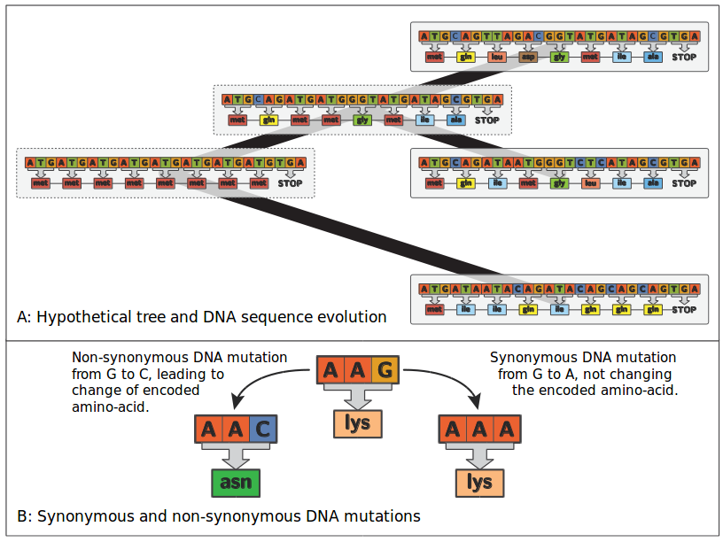
Figure 1: Hypothetical tree and protein coding DNA sequence evolution.
The Kimura formula states that the rate of substitution is equal to the rate of mutation multiplied by the probability of fixation of the mutation. Crucially, the probability of fixation depends on the difference of fitness between the mutated sequence and the original sequence. Recent advancement in so called mutation-selection codon substitution models use Kimura’s mathematical formula to derive an alternative to the null hypothesis of neutrality[13][14].
In mutation-selection codon models, the probability of reaching fixation is different for any non-synonymous mutation. More specifically, it will depend on the original amino-acid preference and the mutated amino-acid preference encoded by the codon (see box 2). From a dynamical perspective, a mutation on a codon with high preference (of the encoded amino-acid) will have a low probability of fixation, since the mutated codon will have a lower preference, and thus at equilibrium this low probability of fixation of the codon is compensated by an high frequency of the codon. And essentially, at equilibrium the codon frequencies only fluctuates at the mutation-selection balance, hence the name nearly-neutral models I will use in this review.
For evolutionnary biologists, the assumption of equal amino-acid preference of the neutral model is equivalent to have a flat fitness landscape for all amino-acids, with neither a peak nor a valley. In contrast, in nearly-neutral models, the amino-acid have a fitness landscape fixed in time, but that is not flat. The difficulty and complexity of nearly-neutral models is to estimatie the underlying amino-acid fitness landscape[15]. Moreover, the nearly-neutral models considers multiplicative fitness across-sites.
Nearly-neutral models display the important feature of genuinely accounting for purifying selection. Indeed Spielman and Wilke showed mathematically in 2015[14] that if the underlying process is a nearly-neutral one, the estimated ω by the neutral model will always be lower than 1 (whatever the codon preferences). In other word, if one use a neutral codon substitution model while the equal codon preference assumption is broken, it will be interpreted as purifying selection (ω<1). Notably, if only one amino-acid has a very high preference when all they others have a it low, the estimated ω will tend to 0.
A first approximation of nearly-neutral models is that all the positions of the sequence share the same amino-acid preferences. But it has been rapidly recognized that each site in the codon sequence should have its own independent codon preferences [14][13][16]. Site-specific amino-acid preferences have been estimated either by maximum likelihood[16][17], by experimental means[18], or, have been considered as random-effects integrated over a distribution [19], that sometimes w non-parametrically estimated with Dirichlet process priors [20][19].
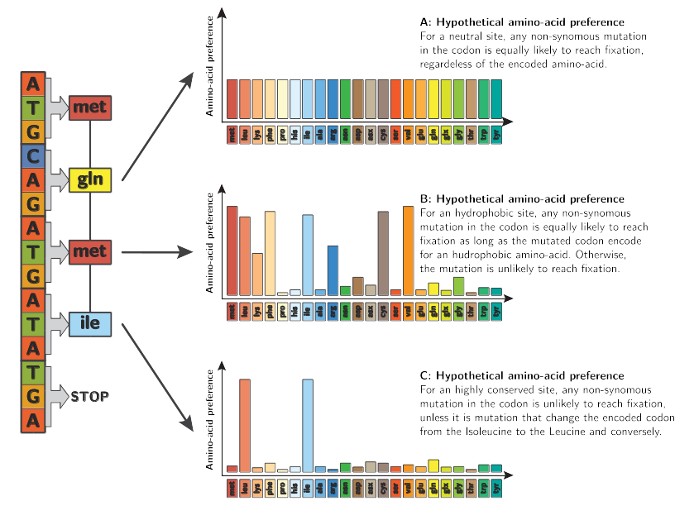
Figure 2: Nearly-neutral models of codon substitution.
Once the amino-acid preferences are estimated, the nearly-neutral model is set, and one can estimate the deviation from nearly-neutrality usually with the parameter ω∗. As in neutral model, ω∗ is the ratio of the non-synonymous over the synonymous substitution rates, but the non-synonymous substitution rate is weighted by the probability fixation induced by the amino-acid preferences (see box 2)[21][22][18].
Specifically, protein adaptation would require to produce a ω>1 to be detected, which only concern very strong adaptation, but would be detected as long as they produce a ω∗>1.
Firstly, the nearly-neutral assumption can be broken is if amino-acid have a time-dependent preference. This phenomenon is known as a red-queen process. In this case, by definition, the protein sequence is tracking a constantly moving fitness optimum. Since the protein sequence is always lagging behind the moving target defined by the amino acid preferences, and since substitutions are accepted preferentially if they are in the direction of this target, substitutions are on average adaptive. Thus breaking the assumption of time independence of amino-acid preferences leads to ω∗>1.
Secondly, the nearly-neutral assumption also can be broken if there is no independence between sites. This phenomenon is known as epistasis between sites. In reality, it is suspected that epistasis represents an important feature of protein evolution [23][24][16]. Unfortunately, one consequence of epistatic interactions is that even if a mutation is nearly neutral upon fixation, subsequently fixed mutations makes its reversion more and more deleterious over time. This effect relies on a dependence of subsequent substitutions on the firstly fixed one.. Thus, breaking the assumption of independence between sites leads to ω∗<1.
To summarize, a departure from nearly-neutrality with a ω∗>1 is a signature of an ongoing red-queen process and that the protein is under ever changing adaptation. On the other hand a ω∗<1 is a signature of epistatic interaction between amino-acid. But one shortcoming of nearly-neutral codon substitution models is that if one doesn’t get a statistical departure from nearly-neutrality (ω*=1), it could be due to a mixture of both red-queen and epistatic process that cannot be untied.
In a computational perspective, testing a deviation from nearly-neutrality is more intensive than testing a deviation from neutrality.

Comparing and combining the models
We saw that variouscodon substitution models can be used to detect and quantify positive and negative selection in protein coding sequences, as a deviation from neutrality or from nearly-neutrality. And as such these models must be compared rigorously, in order to enable the selection of the more adapted model, based on mathematical rational and goodness of fit of the model to the data. It is also necessary to make sure that the assumptions made by this models are not broken. But beside the detection and quantification of protein adaptation, codon substitution models are used to construct phylogenies. Thus it is crucial to select models that correctly reproduce the underlying evolutionary process, otherwise the reconstructed trees will be meaningless and more dramatically will lead to false conclusions. Model comparison and selection can be studied in both Maximum likelihood and Bayesian context
In a Maximum likelihood framework, the simplest case of model selection is the nested models. Models are called nested if for a particular set of values of one of them, both models are the same. In our codon substitution models, the neutral model is nested to the nearly-neutral model.I Indeed by setting all the codon preferences to 1, the nearly-neutral models become a neutral model. In the case of nested model, the ratio of maximum likelihood obtained must follow a Chi-squared distribution. Thus if the likelihood ratio is greater than expected theoretically, one can have mathematical rational for selecting such a model. In the case the models are not nested, a more flexible approach such as Akaike Information Criterion (AIC, see box 1) can be used to perform model selection. In the maximum likelihood context, the nearly-neutral model with site-specific amino-acid preferences greatly improves the identification of positive selection and goodness of fit [18].
In a Bayesian framework, the Bayes factor (see box 1) provides a natural framework for comparison of models, with the advantage of being applicable to the comparison of any pair of models and intrinsically penalizing for high-dimensional formulations. Notably, Bayes factor does not require models to be nested. Unfortunately, evaluating the Bayes factor for complicated models is computationally intensive and requires elaborate techniques such as thermodynamic integration[25]. In practice, the Bayes factors reveals considerable differences in codon substitution model performance, indicating the importance of conducting a careful examination assumption[6]. On real and simulated data, comparison of the codons substitution models shows that nearly-neutral models, with a Dirichlet process for estimating the distribution of amino-acid preference is the model which performs the best overall [6][26]. Unfortunately, this model is computationally intensive and requires quite many data, and should not be taken as a the reference. Instead this model should be tested thoroughly and its limit should be clearly stated.

References and recommended reading
Papers of particular interest have been highlighted as:
of special interest
of outstanding interest

1. Muse SV, Gaut BS: A likelihood approach for comparing synonymous and nonsynonymous nucleotide substitution rates, with application to the chloroplast genome. Mol. Biol. Evol. 1994, 1:715–724.
2. Goldman N, Yang Z: A codon-based model of nucleotide substitution for protein-coding DNA sequences. Mol. Biol. Evol. 1994, 11:725–736.
3. Yang Z, Nielsen R, Goldman N, Pedersen AK: Codon-substitution models for heterogeneous selection pressure at amino acid sites. Genetics 2000, 155:431–449.
4. Yang Z: Codon-substitution models to detect adaptive evolution that account for heterogeneous selective pressures among site classes. Mol. Biol. Evol. 2002, 19:49–57.
5. Yang Z, Wong WSW: Bayes empirical bayes inference of amino acid sites under positive selection. Mol. Biol. Evol. 2005, 22:1107–1118. [doi: 10.1093/molbev/msi097]
6. Rodrigue N, Lartillot N: Bayesian comparisons of codon substitution models. Genetics 2008, 1591:1579–1591. [doi: 10.1534/genetics.108.092254]
7. Huelsenbeck JP, Jain S, Frost SWD, Pond SLK: A Dirichlet process model for detecting positive selection in protein-coding DNA sequences. Proc. Natl. Acad. Sci. 2006, 103:6263–6268. [doi: 10.1073/pnas.0508279103]
8. Yang Z: Synonymous and nonsynonymous rate variation in nuclear genes of mammals. J. Mol. Evol. 1998, 46:409–418.
9. Yang Z: Codon-substitution models for detecting molecular adaptation at individual sites along specific lineages. Mol. Biol. Evol. 2002, 19:908–917.
10. Zhang J, Nielsen R: Evaluation of an improved branch-site likelihood method for detecting positive selection at the molecular level. Mol. Biol. Evol. 2005, 22:2472–2479. [doi: 10.1093/molbev/msi237]
11. Pond SLK, Murrell B, Fourment M, Frost SDW, Delport W, Scheffler K: A random effects branch-site model for detecting episodic diversifying selection. Mol. Biol. Evol. 2011, 28:3033–3043. [doi: 10.1093/molbev/msr125]
12. Guindon S, Rodrigo AG, Dyert KA, Huelsenbeck JP: Modeling the site-specific variation of selection patterns along lineages. Proc. Natl. Acad. Sci. U. S. A. 2004, 101:12957–12962. [doi: 10.1073/pnas.0402177101]
13. Tamuri AU, Goldman N, dos Reis. M: A penalized-likelihood method to estimate the distribution of selection coefficients from phylogenetic data. Genetics 2014, 197:257–271. [doi: 10.1534/genetics.114.162263]
14. Spielman SJ, Wilke CO: The relationship between dN/dS and scaled selection coefficients. Mol. Biol. Evol. 2015, 32:1097–1108. [doi: 10.1093/molbev/msv003]
15. Halpern AL, Bruno WJ: Evolutionary distances for protein-coding sequences: modeling site-specific residue frequencies. Mol. Biol. Evol. 1998, 15:910–917.
16. Gong LI, Bloom JD: Epistatically Interacting Substitutions Are Enriched during Adaptive Protein Evolution. PLoS Genet. 2014, 10. [doi: 10.1371/journal.pgen.1004328]
17. Holder MT, Zwickl DJ, Dessimoz C: Evaluating the robustness of phylogenetic methods to among-site variability in substitution processes. Philos. Trans. R. Soc. Lond. B. Biol. Sci. 2008, doi:10.1098/rstb.2008.0162. [doi: 10.1098/rstb.2008.0162]
18. Bloom JD: Identification of positive selection in genes is greatly improved by using experimentally informed site-specific models [Internet]. bioRxiv 2016, doi:10.1101/037689. [doi: 10.1101/037689]
19. Rodrigue N, Lartillot N: Site-heterogeneous mutation-selection models within the PhyloBayes-MPI package. Bioinformatics 2013, [no volume].
20. Rodrigue N, Philippe H, Lartillot N: Mutation-selection models of coding sequence evolution with site-heterogeneous amino acid fitness profiles. Proc. Natl. Acad. Sci. 2010, 107:4629–4634. [doi: 10.1073/pnas.0910915107]
21. Yang Z, Nielsen R: Mutation-selection models of codon substitution and their use to estimate selective strengths on codon usage. Mol. Biol. Evol. 2008, 25:568–579. [doi: 10.1093/molbev/msm284]
22. Robinson DM, Jones DT, Kishino H, Thorne JL: Protein evolution with dependence among codons due to tertiary structure. Mol. Biol. Evol. 2003, 20:1692–1704. [doi: 10.1093/molbev/msg184]
23. Lunzer M, Golding GB, Dean AM: Pervasive cryptic epistasis in molecular evolution. PLoS Genet. 2010, 6. [doi: 10.1371/journal.pgen.1001162]
24. Mccandlish DM, Rajon E, Shah P, Ding Y, Plotkin JB: The role of epistasis in protein evolution. Nature 2013, 497:E1–E2. [doi: 10.1038/nature12219]
25. Biochimie DD, Montreal UD: Computing bayes factors using thermodynamic integration. Syst. Biol. 2006, 55:195–207. [doi: 10.1080/10635150500433722]
26. Rodrigue N, Lartillot N, Lyon D: Detecting adaptation in protein-coding genes using a Bayesian site- heterogeneous mutation-selection codon substitution model. Mol. Biol. Evol. 2016, doi:10.1093/molbev/msw220. [doi: 10.1093/molbev/msw220]

